CST 2120 - Coursework 1 Game Website Report

Game Title: Trekking Disaster
Student Name: Tyrone Jusley Calajate
MISIS: M00986297



Introduction
Trekking Disaster is a fun and simple browser game where the goal is to survive by collecting food while dodging falling rocks. The player controls a small pixel-style character who moves left and right across the screen to catch consumables and avoid obstacles. The game is built using HTML, CSS, and JavaScript, and it can be played on any web browser, as long as you have the code running in your device.

Website Pages Overview
My game website has several pages that work together to create the full game experience. Each page has a purpose and helps guide the player through the website smoothly.
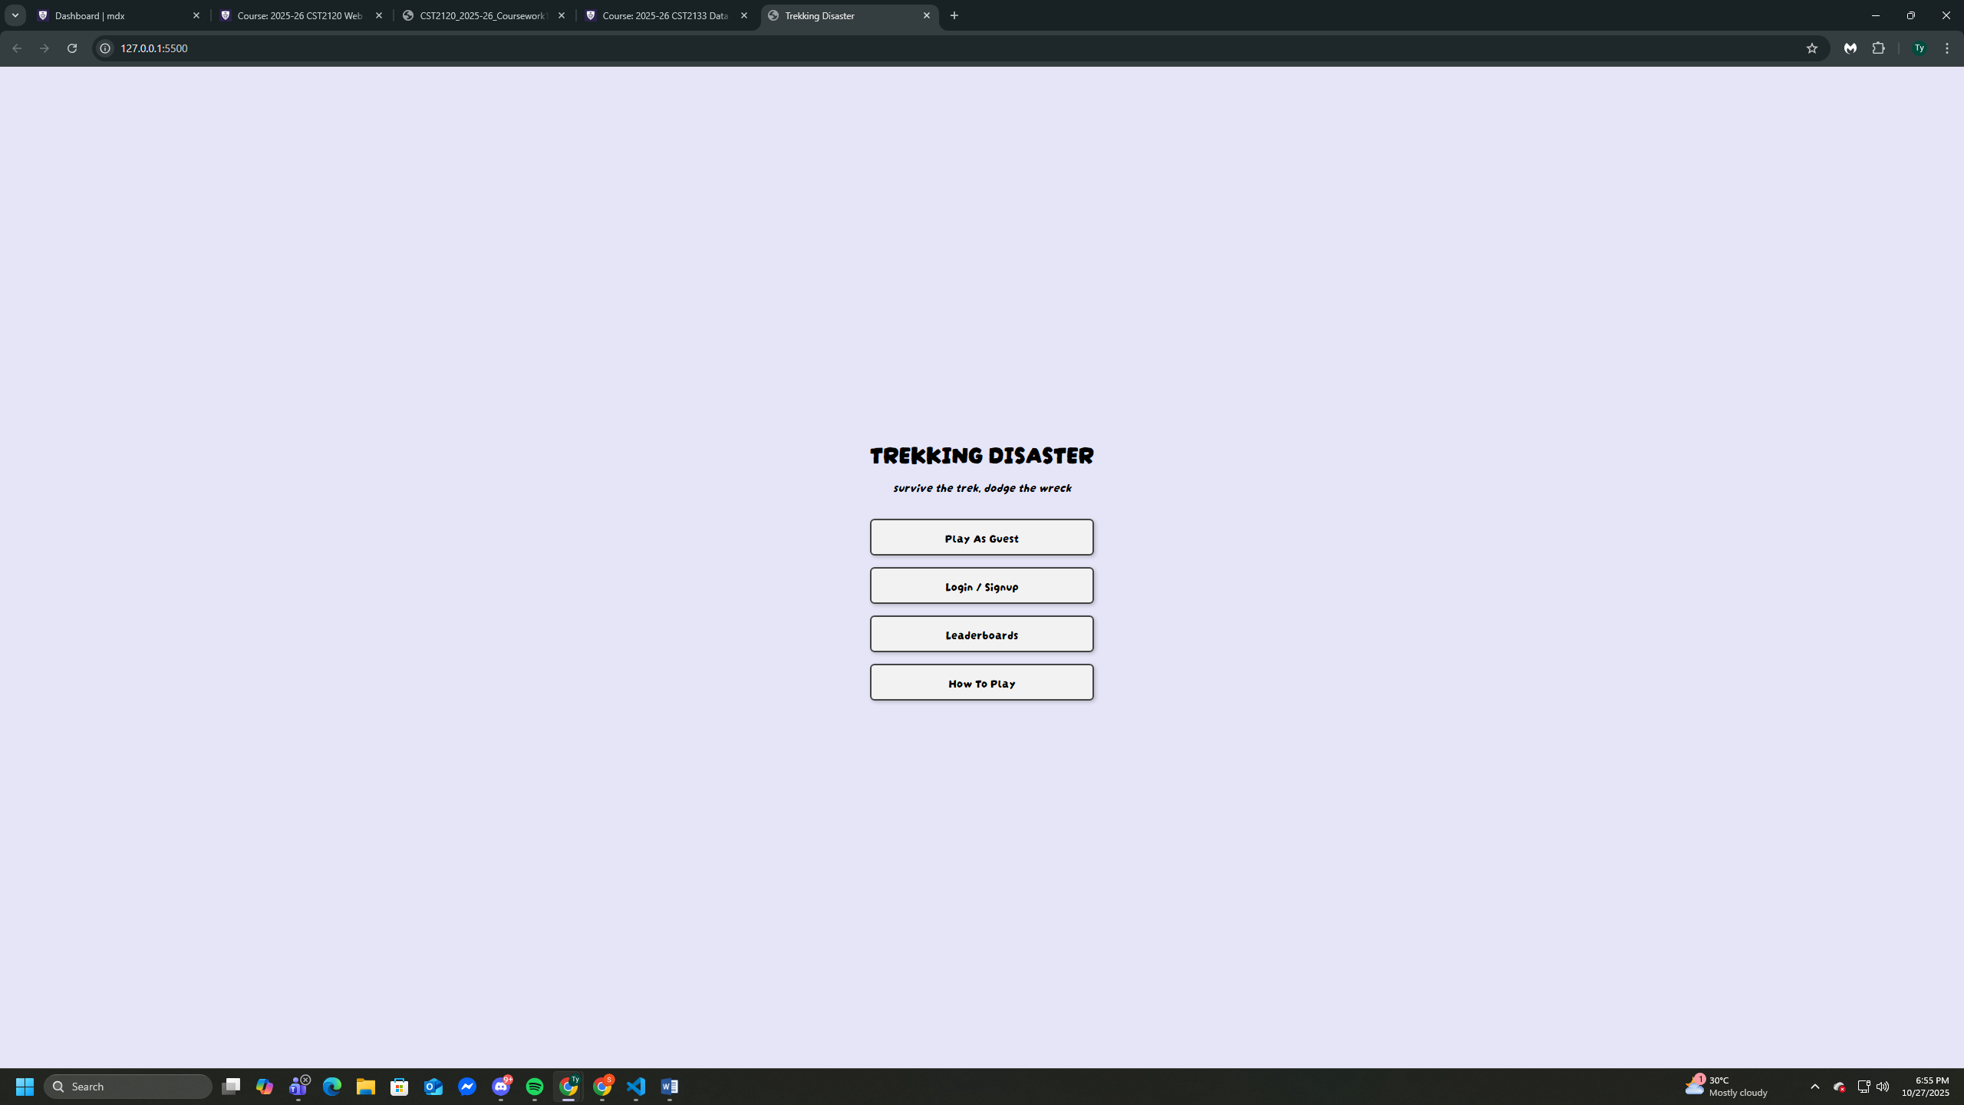
Main Menu (index.html): The starting screen where players can choose to play as a guest, log in, check the leaderboard, or read the “How to Play” instructions. It also detects if someone chooses to play as a guest so the game knows not to save their score. I wanted it to be simple and easy to navigate.
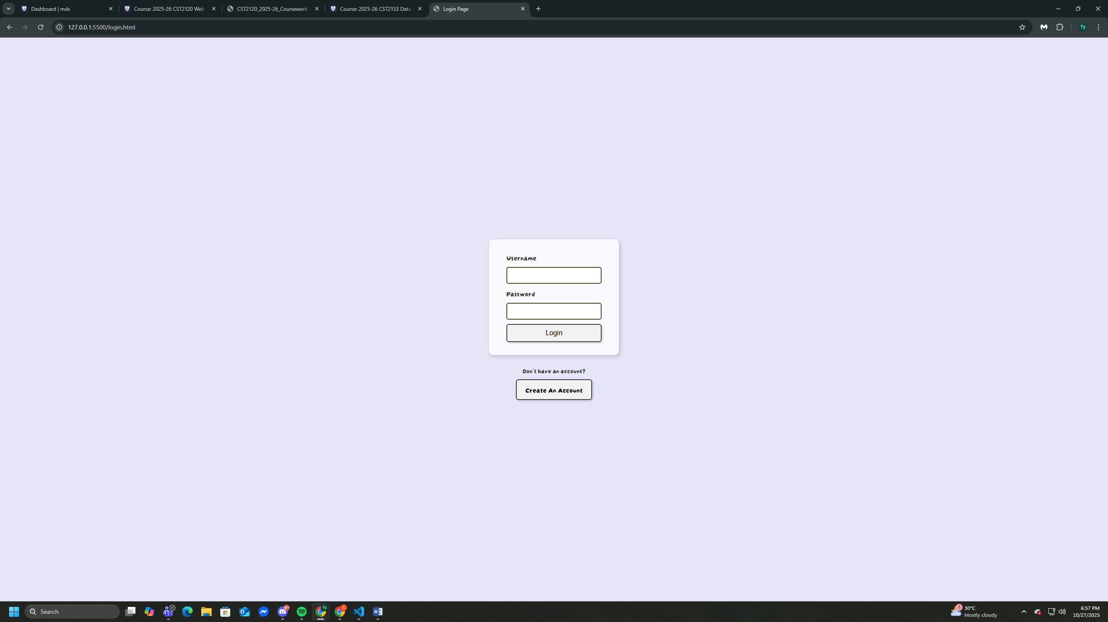
Login Page (login.html): The login page lets returning players access their accounts. It checks that the fields aren’t empty and that the email and password match what is stored. This allows signed-in users to save their scores to the leaderboard.

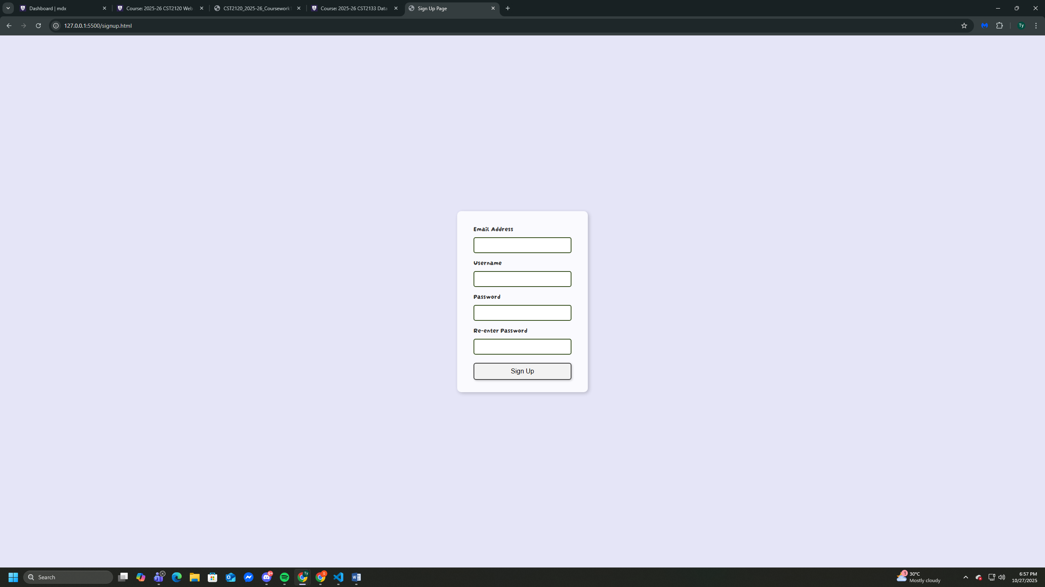
Sign Up Page (signup.html): This page creates new accounts. It collects an email, username, and password, and make sure the two password fields match. This helped avoid random mistakes during sign up and keeps the user process smooth and friendly.

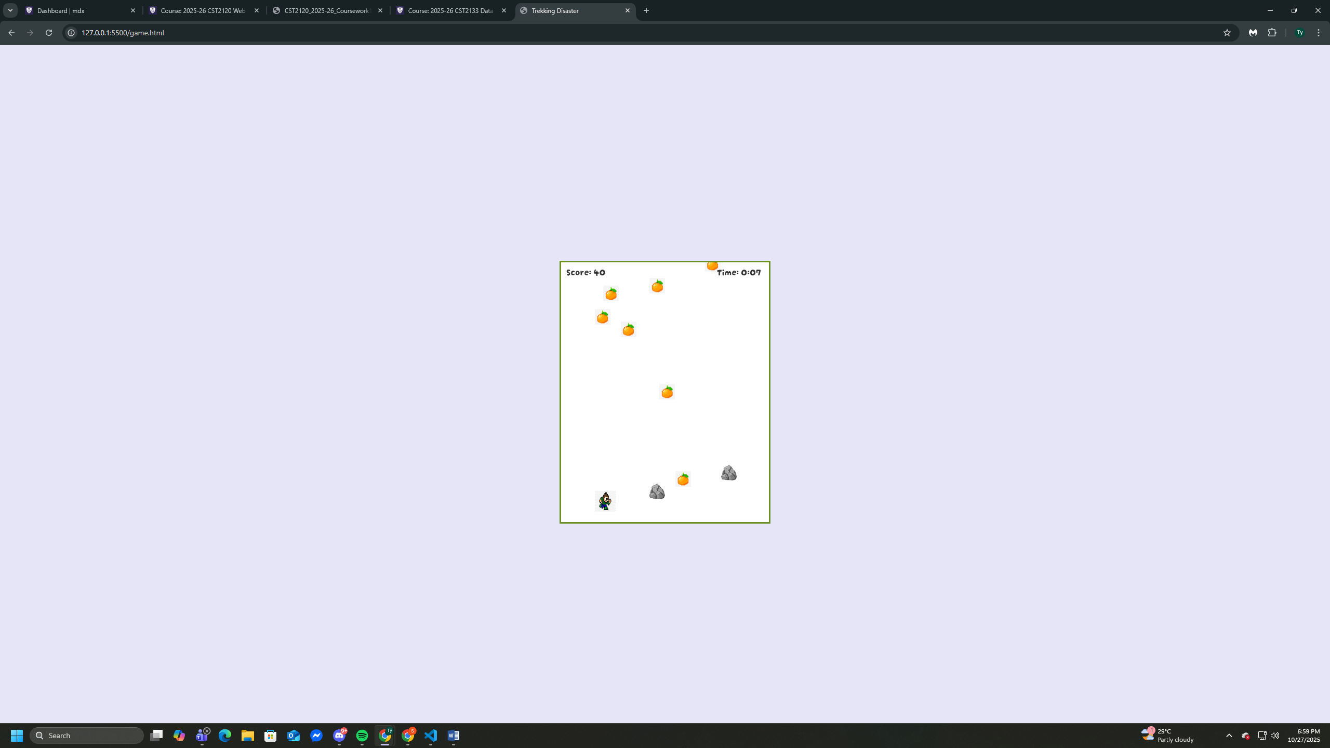
Game Page (game.html): This is where the actual gameplay happens. Players move left and right to collect food and avoid rocks. Guests can still play normally, but only logged-in users get their scores saved.

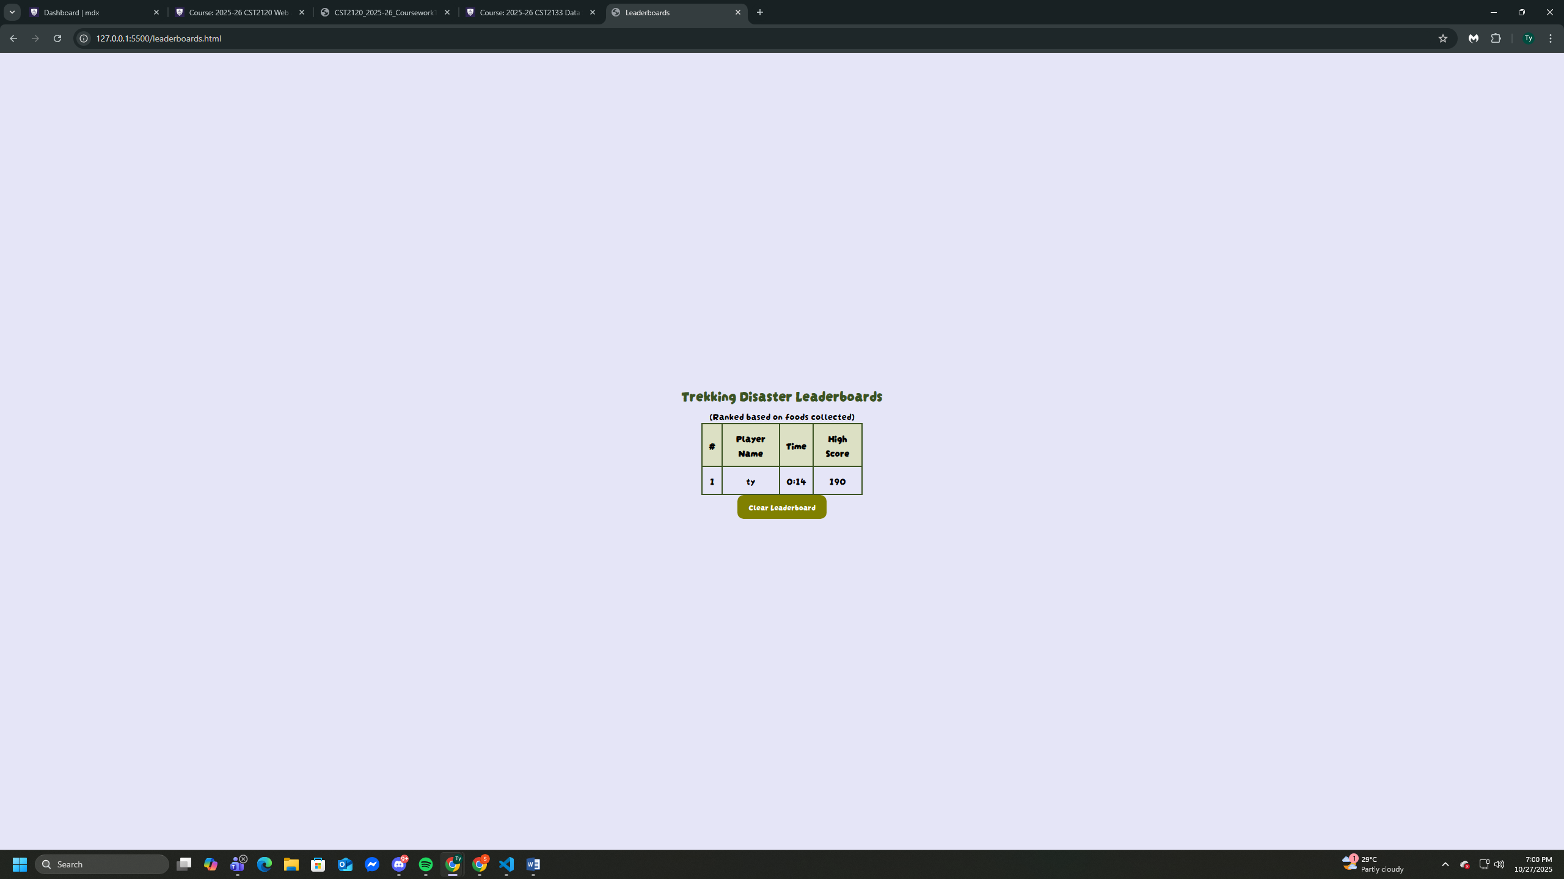
Leaderboard Page (leaderboard.html): This page shows the top scores from signed-in users. It only keeps the best score per user and replaces it if they achieve a higher one later. Everything is saved in localStorage for this project, which worked well for this scale.

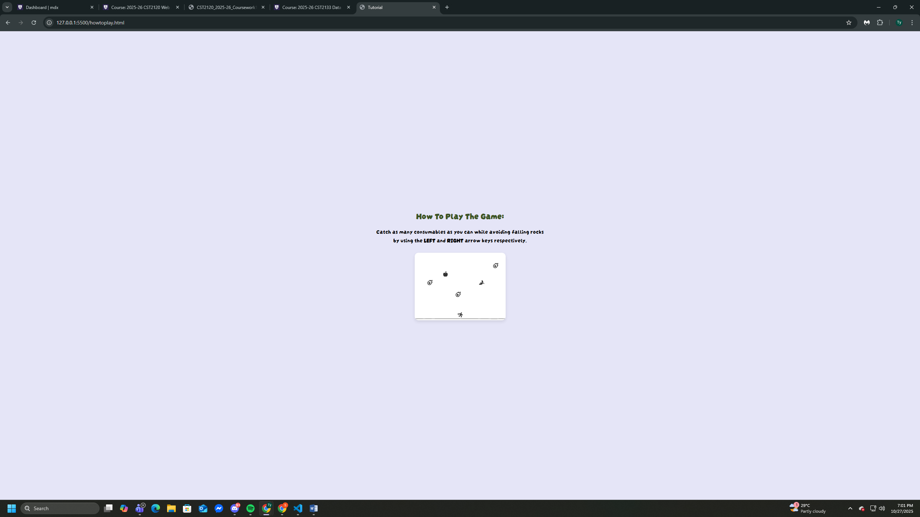
How to Play Page (howtoplay.html): This page simply explains the controls and rules so players understand how to play before starting.

Content of the Report
The main purpose of Trekking Disaster is to give players a simple but engaging survival challenge. The game logic is handled through JavaScript. Each time a player catches food, their score goes up by 10 points. If a rock hits them, the game ends and a “Game Over” screen appears showing their score and total play time. From there, players can choose to play again or go back to the main menu. The game also has a system that distinguishes between guests and logged-in users. Guests can play freely but their scores are not saved. Logged-in players, on the other hand, have their usernames stored and their top scores recorded in the leaderboard. The leaderboard only shows one record per player and their highest score. This helps keep the rankings fair and clean. Login and signup pages include simple validation to check that passwords match and fields are filled in correctly, ensuring a smooth user experience.
Development
The development of Trekking Disaster began by creating a wireframe for each website pages, then designing the main structure of the website using HTML and applying consistent styling across all pages with CSS. Once the navigation between pages such as the main menu, login, signup, leaderboard, and how-to-play sections was working, I focused on programming the game’s functionality using JavaScript. The main game logic handles the spawning of falling food and rocks, movement of the player, collision detection, and score tracking. I also implemented a timer and a “Game Over” screen with buttons to replay or return to the main menu.
Challenged I Faced
One of the biggest challenges in my project was getting the collision detection to work smoothly so the player could collect food without objects clipping or not registering hits. At first, the collision either triggered too late or didn’t trigger at all. I solved this by using bounding-box collision and checking the player’s x and y ranges against the failing object’s size. This allowed me to remove the food properly and add points when they overlapped. The collision logic can be seen in my isColliding() function in game.js, where it compares positions and sizes of objects.
Another challenge was making sure the leaderboard didn’t create multiple entries for the same player. In the beginning, every run added a new score line, even if the same user already existed. To fix this, I stored results in localStorage and then filtered them so only the highest score per user stayed. I used a JavaScript object to detect duplicates and then kept only the best score before displaying it on the leaderboard page. This made the leaderboard much cleaner and fair. Managing guests versus registered users was also tricky because I needed a way to let guests play freely but prevent their scores from being saved. I solved this by storing a temporary flag using sessionStorage.setItem(“isGuest”, true/false) when the player clicked “Play” on the home pages. In the game code, I then checked that flag before saving scores, which ensured only registered users had their results recorded.
Finally, another major challenge was making sure the game actually stopped when the player lost. At first, the update loop kept running in the background and the objects continued falling. I fixed this by setting a gameOver flag that stops the update loop, shows the Game Over screen, and pauses the timer. This gave me a clean ending and made restarting smooth.
Conclusion
Overall, this project helped me grow both technically and creatively. I learned how to plan multi-page website, manage user data with localStorage, and build a functioning browser game from scratch. It also improved my debugging skills and patience because I had to repeatedly test and adjust features until they worked correctly. Even though some parts were confusing at first, solving those problems gave me more confidence in my programming abilities. I am proud of the outcome, and this experience has motivated me to keep learning and building more interactive web projects like these in the future.

